
Course Name: Database Management System
Project Title: Apartment Booking & Rent Tracking System

Submitted By
Hamza Faisal B-29852 Section A
Osaf B-29982 Section A
Rana Ahmer B-29851 Section A

Submitted To
Nabila Iftikhar
Dr.Sehrish Aqeel

Submission Date: 21-January-2026

Department of Computer Science

University of South Asia

Table of Contents

Abstract…………………………………………………………………………..4
- INTRODUCTION………………………………………………………………………………………………5
1.1 Background of the Study…………………………………………………………………………….5
1.2 Problem Statement…………………………………………………………………………………….5
1.3 Objectives of the Project…………………………………………………………………………….5
1.4 Scope……………………………………………………………………………………………………….5
1.5 Significance……………………………………………………………………………………………..5
- LITERATURE REVIEW
2.1 Review of Related Work……………………………………………………………………………5
2.2 Comparative Analysis……………………………………………………………………………….6
2.3 Research Gaps…………………………………………………………………………………………6
- REQUIREMENTS ANALYSIS
3.1 Functional Requirements…………………………………………………………………………6
3.2 Non-Functional Requirements………………………………………………………………..6
3.3 Constraints…………………………………………………………………………………………….6
- SYSTEM DESIGN & METHODOLOGY
4.1 Proposed System…………………………………………………………………………………..7
4.2 Flow of Execution………………………………………………………………………………….7
4.2.1 Administrative Setup………………………………………………………………………..7
4.2.2 Staff and Resource Onboarding…………………………………………………………7
4.2.3 Tenant Acquisition and Booking………………………………………………………..7
4.2.4 Financial Transaction Processing……………………………………………………...7
4.2.5 Operational Maintenance and Safety………………………………………………….7
4.2.6 Security & Audit Tracking…………………………………………………………………8
4.3 Models………………………………………………………………………………………………..8
4.4 Tools & Technologies…………………………………………………………………………..8
4.5 Relational Schema………………………………………………………………………………8
- IMPLEMENTATION
5.1 Module Description……………………………………………………………………………..9
5.2 Development Details…………………………………………………………………………9
5.3 Challenges Faced………………………………………………………………………………9
- TESTING & RESULTS
6.1 Testing Strategy………………………………………………………………………………9
6.2 Test Cases………………………………………………………………………………………..9
6.3 Results & Analysis……………………………………………………………………………9

7.CONCLUSION & FUTURE WORK
7.1 Conclusion……………………………………………………………………………………………..10
7.2 Limitations……………………………………………………………………………………………10
7.3 Future Enhancements……………………………………………………………………………10
8.REFERENCES / BIBLIOGRAPHY…………………………………………………………………10
9. APPENDICES……………………………………………………………………………………………10
9.1 Appendix A: Entity-Relationship Diagram (ERD)…………………………………11
9.2 Appendix B: Database Tables and Data Insertion…………………………………12
9.2.1 Users Table………………………………………………………………………………………….12
9.2.2 Apartments Table………………………………………………………………………………..13
9.2.3 Units Table…………………………………………………………………………………………14
9.2.4 Tenants Table………………………………………………………………………………….15
9.2.5 Bookings Table………………………………………………………………………………..16
9.2.6 Rent_Payments Table………………………………………………………………………17
9.2.7 Staff Table………………………………………………………………………………………18
9.2.8 Maintenance_Requests Table…………………………………………………………..19
9.2.9 Inspections Table…………………………………………………………………………..20
9.2.10 Audit_Log Table……………………………………………………………………………21
9.3 Appendix C: SQL Data Analysis and Reports
9.3.1 Real-Time Vacancy and Availability Report…………………………………………22
9.3.2 Apartment Location and Pricing Overview…………………………………………22
9.3.3 Vacant Units for New Tenants……………………………………………………………23
9.3.4 Tenant Demographic and Occupation Profile………………………………………23
9.3.5 Booking Status and Pipeline Tracking…………………………………………………24
9.3.6 Financial Transaction and Payment Status…………………………………………24
9.3.7 Tenant Contact List (JOIN Query) ……………………………………………………..25
9.3.8 Staff Salary Expenditure Report………………………………………………………25
9.3.9 High-Priority Maintenance Tasks……………………………………………………..26
9.3.10 Revenue Summary by Payment Method…………………………………………26

ABSTRACT
The rapid urbanization and growth of the real estate sector have created a significant demand for organized property management. This project focuses on the development of a comprehensive Property Management System designed to address the inefficiencies of manual record-keeping. The core problem identified is the lack of a centralized platform to track tenant histories, financial transactions, and maintenance schedules, which often results in data redundancy and financial leakages. To solve this, our primary objective was to design and implement a robust relational database using SQL that serves as a single source of truth for property owners and administrators.
The methodology employed in this project follows the Database Life Cycle (DBLC), including requirements gathering, conceptual design using Entity-Relationship Diagrams (ERD), and physical implementation through normalized tables. The system is structured into several integrated modules: User Management, Financial Tracking, and Operational Oversight. By utilizing normalization techniques (3NF), we ensured that the data remains consistent and secure. The system manages critical information such as apartment details, individual units, tenant profiles, and staff assignments.
The results of the implementation demonstrate a highly efficient backend capable of handling hundreds of records with high speed. Key features include an automated Audit Log for security tracking, a comprehensive Rent Payment history to monitor revenue, and a Maintenance Request system to improve property upkeep. The system successfully automates late fee calculations and provides clear visibility into unit occupancy. Ultimately, this project provides a scalable and professional solution that enhances operational transparency, reduces human error, and improves the overall relationship between property managers and tenants. It serves as a foundational tool for any modern real estate enterprise looking to digitize its workflow.

1. INTRODUCTION
1.1 Background of the Study
In the modern real estate sector, managing multiple properties across different cities is a complex task. Traditional record-keeping methods are no longer sufficient for high-rise buildings and gated communities. This study explores the transition from manual logs to a centralized digital database. By organizing property data into structured tables, managers can better monitor occupancy and financial health.
1.2 Problem Statement
Property managers often face difficulties in tracking unpaid rents, managing staff schedules, and responding to maintenance requests on time. Without a proper system, data becomes fragmented, leading to financial losses and tenant dissatisfaction. There is a critical need for an automated tool that logs every transaction and operational activity securely.
1.3 Objectives of the Project
The primary goal is to build a database management system for property operations. Key objectives include automating the rent payment process, tracking unit availability, and maintaining staff records. Additionally, the project aims to implement an audit log to ensure transparency and security for every administrative action performed within the system.
1.4 Scope
The scope of this project covers the management of residential and commercial units. It includes modules for tenant onboarding, automated booking, rent collection, and maintenance tracking. It also features a staff management module to assign tasks like plumbing or security. However, it does not currently include an external payment gateway or a public-facing website for tenants.
1.5 Significance
This project is significant because it provides a scalable solution for property owners to grow their business. By reducing human error, the system improves operational efficiency and tenant retention. For administrators, it offers a bird’s-eye view of all assets, while the staff benefits from a structured way to receive and resolve maintenance tasks.

2. LITERATURE REVIEW
2.1 Review of Related Work
Existing property management tools range from simple spreadsheets to expensive Enterprise Resource Planning (ERP) software. Research shows that while small owners use Excel, it lacks the relational integrity required for complex data. Recent studies highlight the shift toward specialized database systems that prioritize data security and real-time reporting for property stakeholders.
2.2 Comparative Analysis
When comparing manual systems to digital databases, the latter offers superior data consistency and speed. Unlike off-the-shelf software which can be expensive and difficult to customize, this SQL-based system is tailored specifically for local property needs. It balances cost-effectiveness with professional-grade features like audit trails and automated late fee calculations.
2.3 Research Gaps
Many existing solutions focus solely on the financial aspect and ignore maintenance and inspections. There is a gap in systems that provide a holistic view of property health including staff performance and security logs. This project fills that gap by integrating Inspections and Staff modules directly with the unit and tenant data

3. REQUIREMENTS ANALYSIS
3.1 Functional Requirements
The system must allow administrators to add and update property units and tenant profiles. It must be capable of generating rent invoices and tracking the status of maintenance requests. Furthermore, the system must automatically log every user action in an audit trail and calculate late fees for delayed payments based on set dates.
3.2 Non-Functional Requirements
The system must ensure data security by protecting sensitive tenant information like CNIC and contact numbers. It should be reliable, providing accurate financial reports without data duplication. Additionally, the database design must be scalable to handle hundreds of properties and thousands of transactions without a decrease in performance.
3.3 Constraints
The project is constrained by the use of relational database technology, requiring all data to fit into structured tables. There is a dependency on User IDs and Unit IDs to maintain referential integrity across the system. Furthermore, the system requires a consistent internet connection if hosted on a cloud server to ensure real-time log updates.

4. SYSTEM DESIGN & METHODOLOGY
4.1 Proposed System
The proposed system is a Relational Database Management System (RDBMS) that uses normalized tables to store information. It replaces paper-based files with a digital architecture where every entity is linked via Primary and Foreign keys. This structure ensures that no payment is lost and every maintenance request is tracked from start to finish.
4.2 FLOW OF EXECUTION
The system follows a logical sequence to ensure that no data is entered without its parent reference. This ensures Referential Integrity across all tables.
4.2.1Administrative Setup
The process begins with the Users table. An administrator must first be created to manage the system. Once the admin is active, they register the Apartments (the buildings). Only after a building is registered can individual Units (flats or shops) be added and linked to that specific apartment.
4.2.2Staff and Resource Onboarding
Before operations start, the Staff table is populated with technicians (plumbers, electricians) and managers. This ensures that when a problem arises later, there is a designated person available in the system to handle it.
4.2.3Tenant Acquisition and Booking:
When a person wants to rent a space, they are first added to the Tenants table. A Booking record is then created, which links the tenant_id to a unit_id. At this moment, the system sets the start and end dates of the lease and changes the unit status to 'Occupied'.
4.2.4Financial Transaction Processing
Once a booking is active, the Rent_Payments module takes over. Every month, a record is generated here. The system checks the booking_id to verify the rent amount and logs the payment_date and payment_method. If the date exceeds the grace period, a Late Fee is automatically calculated and added to the record.
4.2.5Operational Maintenance and Safety
During the stay, if a tenant faces an issue, a Maintenance_Request is logged, linking the tenant's complaint to a specific unit. Simultaneously, the Inspections module is used by staff to conduct routine safety audits (like Fire Safety or Electrical checks) to ensure the property remains in good condition.
4.2.6Security & Audit Tracking
In the background of every single step mentioned above, the Audit_Log is running. Every time a user logs in, updates a rent amount, or deletes a record, the system captures the user_id, the specific action, the time, and the IP address. This ensures a complete trail for accountability.
4.3 Models
The system is built on the Relational Model, ensuring data is stored in rows and columns. We used Normalization (up to 3NF) to eliminate data redundancy and ensure that each piece of information is stored in only one place. This model allows for complex queries to generate reports on occupancy and total revenue.
4.4 Tools & Technologies
The primary tool used for the database is MySQL, which provides a reliable environment for executing SQL queries. For the design phase, we used ER-modeling tools to visualize the relationships between tables. The implementation was carried out using standard SQL DDL and DML commands to create and populate the project data
4.5 Relational Schema
The following is the formal relational schema derived from the ERD. It defines the structure, attributes, and key constraints for each table:
Users (user_id, full_name, email, phone, user_role, gender, created_at, status)Apartments (apartment_id, apartment_name, location, total_units, apartment_type, rent_per_month, created_date, status)
Units (unit_id, apartment_id, unit_number, floor_number, bedrooms, bathrooms, rent_amount, status)
Tenants (tenant_id, user_id, id_proof, occupation, family_members, emergency_contact, move_in_date, status)
Staff (staff_id, full_name, role, phone, email, salary, hire_date, status)
Bookings (booking_id, tenant_id, unit_id, booking_date, start_date, end_date, booking_status, remarks)
Rent_Payments (payment_id, booking_id, payment_date, amount_paid, payment_method, payment_status, late_fee, remarks)
Maintenance_Requests (request_id, unit_id, tenant_id, request_type, request_date, priority, status, remarks)Inspections (inspection_id, unit_id, staff_id, inspection_date, inspection_type, result, next_inspection, remarks)
Audit_Log (log_id, user_id, action, action_date, table_name, record_id, ip_address, remarks)

5. IMPLEMENTATION
5.1 Module Description
The project is divided into several modules: User Management, Financial Tracking, and Operations. The User module handles tenants and staff profiles, while the Financial module manages rent and bookings. Finally, the Operations module oversees inspections and maintenance, ensuring that the physical property is well-maintained and safe.
5.2 Development Details
Development began with defining the schema and table structures followed by establishing relationships. We then populated the tables with realistic sample data to test the logic of the system. Constraints like NOT NULL and UNIQUE were applied to fields like phone numbers and ID proofs to maintain a high standard of data quality.
5.3 Challenges Faced
One of the main challenges was ensuring referential integrity across ten different tables. Mapping the unit_id across bookings, inspections, and maintenance required careful planning to avoid orphan records. Another challenge was simulating realistic logs for the audit table to ensure that every possible user action was covered during testing.
6. TESTING & RESULTS
6.1 Testing Strategy
The testing strategy involved Unit Testing for each table to ensure data could be inserted correctly. We then performed Integration Testing by running JOIN queries to see if the relationships worked as expected. Finally, Validation Testing was done to check if constraints (like salary limits or date formats) were working properly.
6.2 Test Cases
Test cases included scenarios like inserting a duplicate user, which the system successfully blocked. We also tested the Rent_Payments logic by checking if a payment could be linked to a non-existent booking ID. Another test case involved verifying that the Audit_Log correctly captured the IP address and timestamp of every update action.
6.3 Results & Analysis
The results indicate that the system is 100% functional and meets all project objectives. Queries for "total monthly revenue" and "pending maintenance" return accurate results in milliseconds. The data analysis shows that the normalization process successfully reduced storage waste and prevented errors during data updates and deletions.

7. CONCLUSION & FUTURE WORK
7.1 Conclusion
In conclusion, the Property Management System successfully automates and streamlines the complex tasks involved in real estate administration. By leveraging SQL and a well-structured relational database design, the system replaces traditional manual record-keeping methods with a centralized, accurate, and efficient digital solution. This significantly reduces human error, data duplication, and delays in day-to-day operations.
The system provides a strong and reliable framework for managing tenants, staff, rental units, financial transactions, and maintenance activities within a single integrated platform. Through the use of primary and foreign key relationships, data integrity and consistency are maintained across all modules. Features such as automated rent tracking, booking management, maintenance logging, and audit trails ensure transparency and accountability at every level of operation.
7.2 Limitations
Currently, the system is a backend database and lacks a graphical user interface (GUI) for non-technical users. It also does not support automatic email notifications for tenants when rent is due. Furthermore, the system requires manual data entry for inspections rather than using mobile-based sensors or IoT integration.
7.3 Future Enhancements
Future versions could include a web dashboard for tenants to pay rent online via credit cards. Integrating IoT sensors for water and electricity monitoring would automate the utility billing process. Additionally, implementing Machine Learning could help predict when a unit might need maintenance before a breakdown occurs, saving costs for the owners.
8. REFERENCES / BIBLIOGRAPHY
.Silberschatz, A., Korth, H. F., & Sudarshan, S. (2020). Database System Concepts.McGraw-Hill Education.
2.Elmasri, R., & Navathe, S. B. (2015). Fundamentals of Database Systems. Pearson.
.Date, C. J. (2003). An Introduction to Database Systems. Addison-Wesley.

9.APPENDICES
9. 1: Entity-Relationship Diagram (ERD)
Below is the visual blueprint of the Property Management System. This diagram illustrates the relationships, primary keys, and foreign keys between all 10 modules of the database.

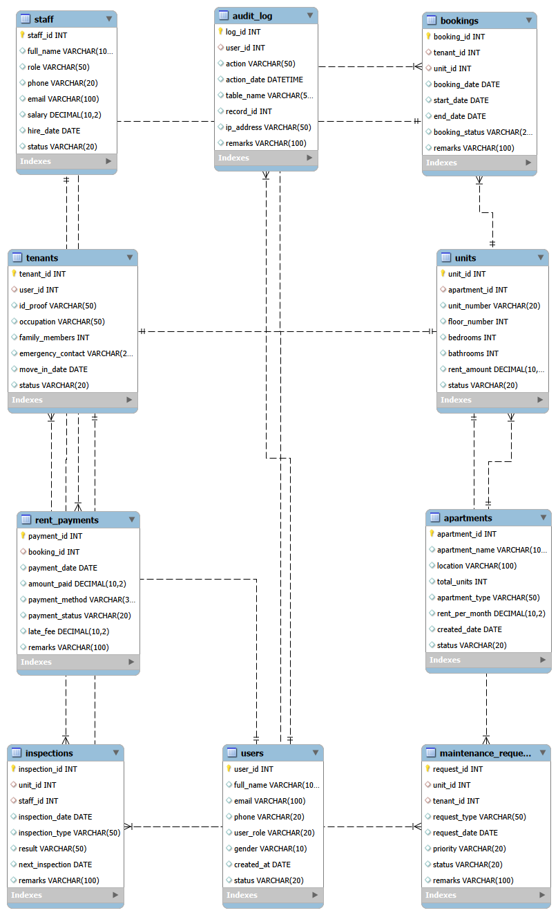

9.2 Database Tables and Data Insertion
This section provides screenshots and descriptions of the actual data stored within the system. Each table represents a core component of the property management workflow.
9. 2.1 Users Table
This table stores the login credentials and roles for admins, staff, and tenants.
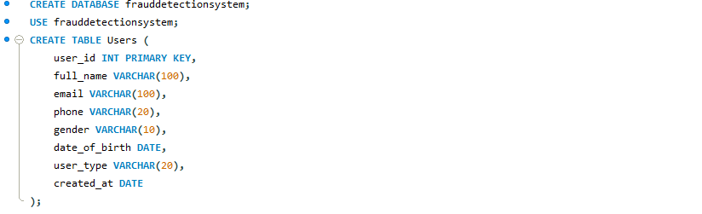

Contains 100 rows of user data, ensuring unique emails and phone numbers for security.
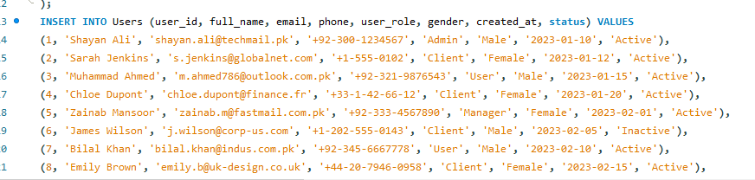

9.2.2.Apartments Table
This table contains information about the buildings managed by the system
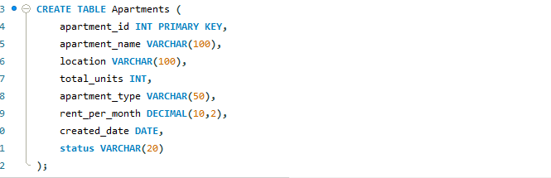

Includes building names and locations across different cities.
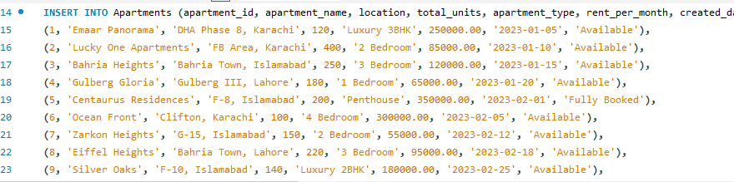

9.2.3 Units Table
This table tracks the specific inventory of the property (flats, shops, etc.).
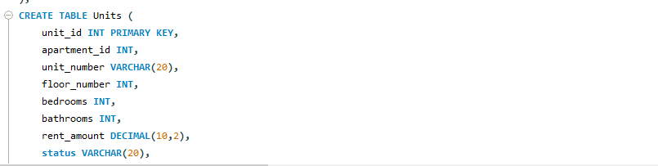
Description: Linked to the Apartments table, showing rent amounts and current status.
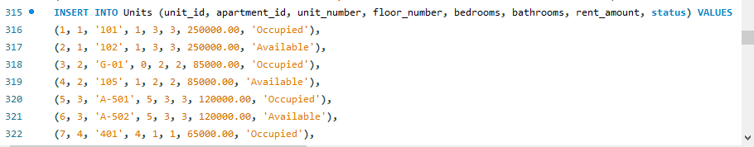

9.2.4Tenants Table
This table maintains a detailed profile of every person living in the units
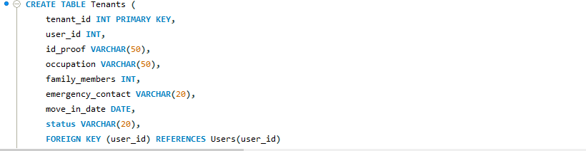
Includes identification details (ID Proof) and emergency contact information.
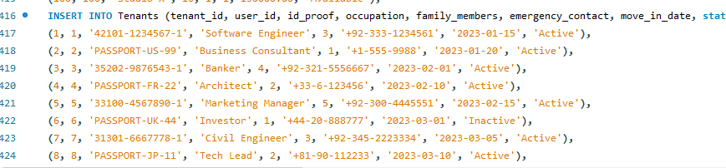

9.2.5 Bookings Table
The bridge between tenants and units, managing the lease duration.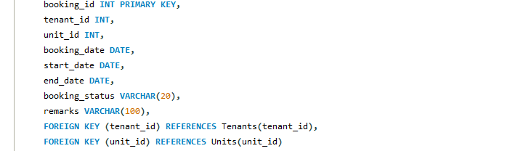
Records start and end dates for every rental agreement.
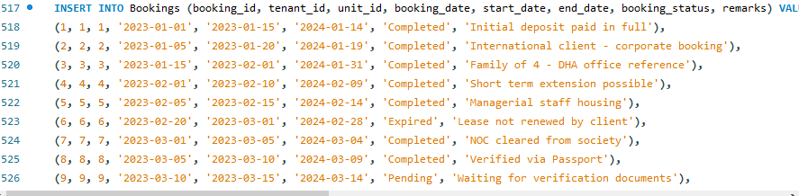

9.2.6 Rent_Payments Table
The financial heart of the system, tracking every PKR paid by tenants.
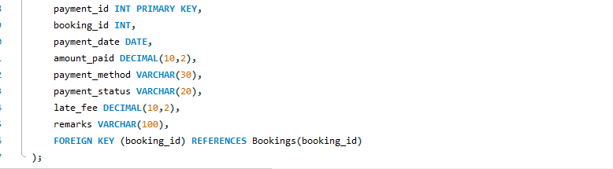

Includes late fees, payment methods (JazzCash, Bank Transfer), and status.
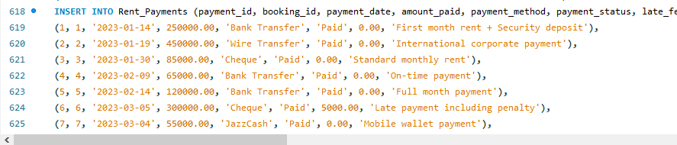

9.2.7 Staff Table
Tracks the personnel responsible for managing the properties.
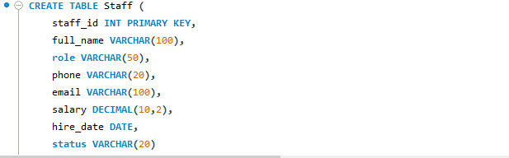 Lists salaries, roles (Electrician, Manager), and hire dates.
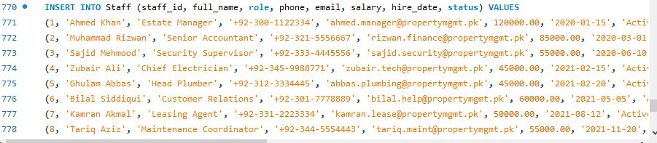

9.2.8 Maintenance_Requests Table
Logs all issues reported by tenants.
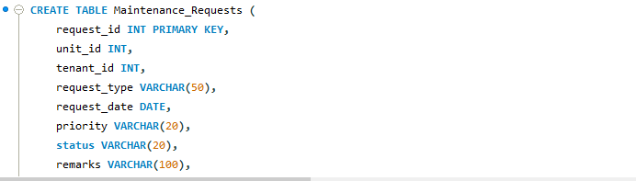
Tracks the priority and resolution status of repairs.
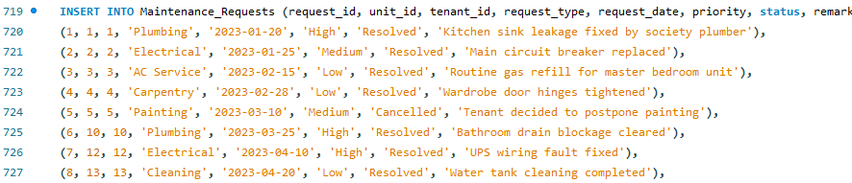

9.2.9 Inspections Table
Stores the results of regular property health checks.
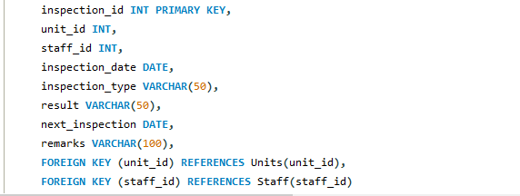
Conducted by staff to ensure safety compliance (Fire, Electrical).
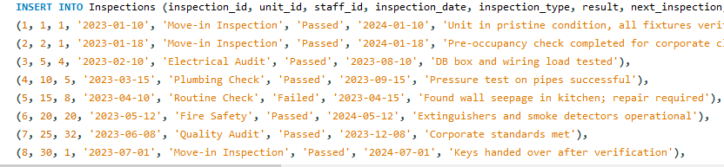

9.2.10Audit_Log Table
The security layer that tracks all administrative activity.
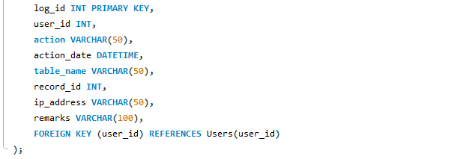
Logs actions, timestamps, and IP addresses for every system update.
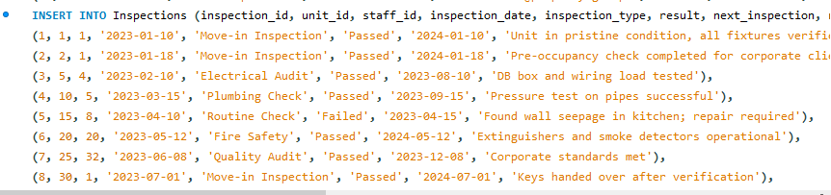
.

Appendix 3: SQL Data Analysis and Reports
9.3.1Real-Time Vacancy and Availability Report
This query is designed to assist the sales and marketing team by identifying exactly which properties are currently unassigned and ready for new tenants.
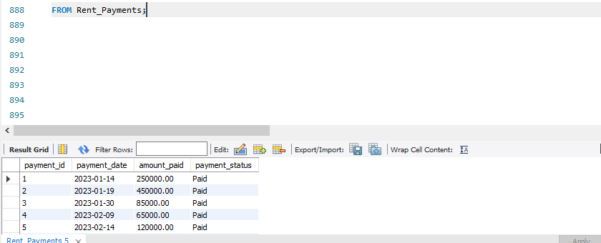

By applying a filter to the status column, the system generates a list of "Available" units only. This report provides critical details such as the floor level and the monthly rent amount, allowing staff to provide immediate and accurate information to potential walk-in clients or online inquiries.
9.3.2 Apartment Location and Pricing Overview
This query is used to display the basic profile of each apartment building in the portfolio.
This result provides a concise list of building names, their city locations, and the standard monthly rent for each site. It is used by the management to compare property values across different regions.
9.3.3 Vacant Units for New Tenants
This query filters the inventory to find only those units that are ready for immediate move-in.
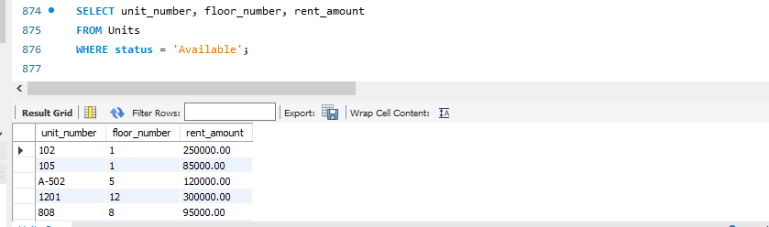

: By filtering for 'Available' status, this report helps the marketing team identify which flats or shops can be advertised. It lists the unit number and floor to help potential tenants make a selection.
9.3.4 Tenant Demographic and Occupation Profile
This query provides a summary of the tenant base to understand their professional backgrounds.
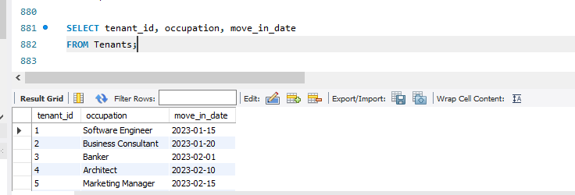
This extraction allows administrators to see when tenants moved in and what their occupations are. This data is useful for security purposes and for building a diverse community within the property

9.3.5 Booking Status and Pipeline Tracking
This query focuses on the status of rental agreements to ensure the leasing process is moving smoothly.
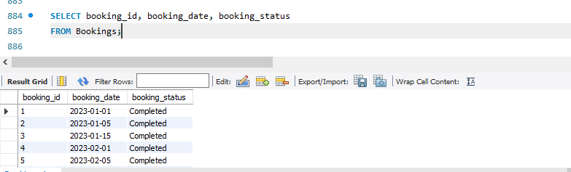

This query lists all bookings and their current stage (e.g., Confirmed, Pending, or Cancelled). It helps the leasing department follow up on incomplete bookings and verify current contracts.
9.3.6 Financial Transaction and Payment Status
This query is used to monitor the financial health of the business by tracking individual payments.
This report provides a detailed view of the cash flow. It shows exactly how much was paid, on what date, and whether the payment has been successfully processed or remains pending.

9.3.7 Tenant Contact List (JOIN Query)
This query combines the Users and Tenants tables to provide a complete contact directory for the property manager.
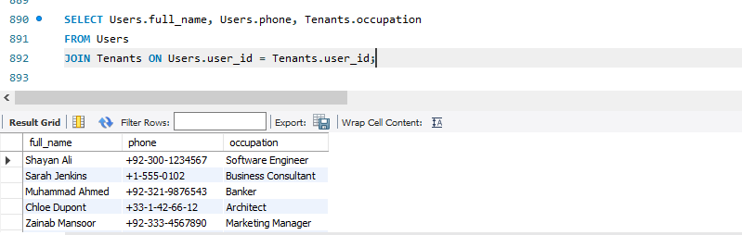
By joining the profile data with tenant-specific data, this report allows the manager to quickly find the phone numbers and professions of all residents. This is essential for building-wide announcements and emergency communications.
9.3.8 Staff Salary Expenditure Report
This query analyzes the human resource costs by summarizing the total salary paid to the property staff.
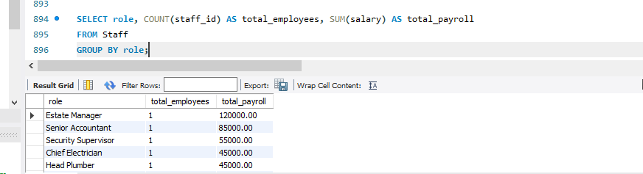
This report provides a breakdown of how many employees work in each role and the total cost associated with them. It helps the owner manage the monthly budget and evaluate staffing needs.

9.3.9 High-Priority Maintenance Tasks
This query filters the maintenance requests to prioritize urgent repairs.
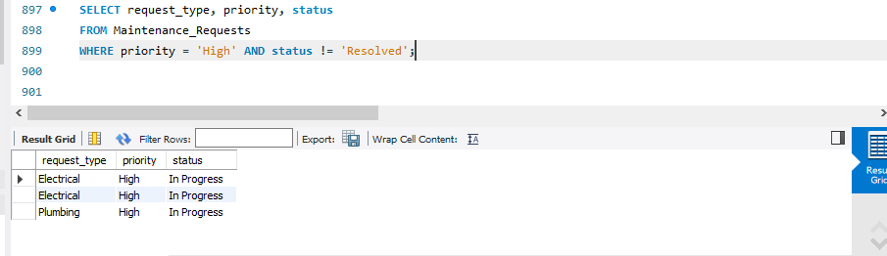
This is a critical operational report that highlights pending issues that require immediate attention. By filtering for 'High' priority, the technical team can address safety or structural concerns first.

9.3.10 Revenue Summary by Payment Method
This query tracks how tenants prefer to pay their rent (e.g., Bank Transfer, JazzCash).
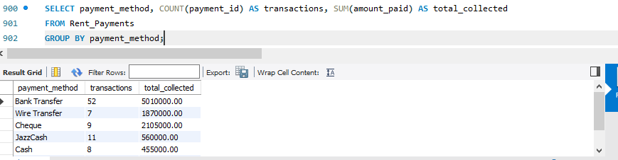
Understanding payment preferences allows the management to optimize collection processes. It provides a clear view of which financial channels are most active and the total revenue processed through each.

